|  |
| --- |
| SDOOP Mini Project |
| Patient Record Management System |
| III Semester ICAS |

Neil Bhutada 181627135

Kirat Alreja 181627132

Manav Bahl 181627136

Arya Sharma 181627134

Table of Contents

1. Do a survey and develop the case study. 2

2. Derive the use cases from the requirements and write the use case diagram 3

3. Write the class diagram (with specification classes) 4

4. Give interaction diagrams for at least three use cases 5

5. Give activity diagram for the whole system 7

6. Show the package diagram of the entire system with clear separation of 3 layers of software architecture 8

7. Generate the source code in Star UML with the language of your choice 9

## 1. Do a survey and develop the case study.

A hospital must use a patient RMS (Record Management System) to store all the necessary details of a patient. The patient record system should be a part of a hospital system, which stores details of the hospital such as location or branch identification number. A doctor record system should also be used to assign doctors as required by patient illness/condition.

The patient record system stores basic information of the patient such as the Name, Phone Number, email and address. To identify the patient from previous visits or for future visits, a patient identification number should be used for every patient in the record. When a patient comes to the hospital & checks in at the reception, a ward should be allotted.

Wards can be allocated in different categories. There are normal, executive & luxury wards to choose from. Each ward category has some extra features like increased bed size & better air conditioning but the basic details like Ward ID are common to all. The food charges are not included in the ward & must be calculated separately. The cost of the ward is calculated on a daily basis, with extra charges for late payment.

A billing system must keep track of all patient’s status of dues. At the end of treatment, the billing system must calculate the total bill including ward, food & miscellaneous charges. A copy of the bill’s ID can be kept for future references.

When doctor is allotted to a patient, doctor system must assign a relevant secondary doctor system for the same. For example - Neurology, Paediatrics or Gastroenterology. A copy of patient’s details will be sent to the subsystem of the secondary doctor department.

Patient record should be the same for OPD patients & Non-OPD Patients. In the case of OPD patients, Ward ID is not applicable & a separate OPD department must be used for calculating bills. The OPD department records should also have a Patient ID for future purposes.

The lab testing department of the hospital is common to all doctor departments. Lab testing is called when a doctor department orders the patient. In that case, the patient details will be shared with the lab test department & a pdf file of the test results will be returned to the doctor department. A copy of lab pdf file is also stored in patient record & is accessible by other doctor departments with prior permission from patient.

The catering section of the hospital must customize food as per instructions sent by the doctor department. When a patient checks in at the reception, food preference such as veg/non veg/ vegan must be taken. When doctor departments wants to set a food instruction for patient as per diagnosis, the instruction & the food preference should be sent to catering.

## 2. Derive the use cases from the requirements and write the use case diagram

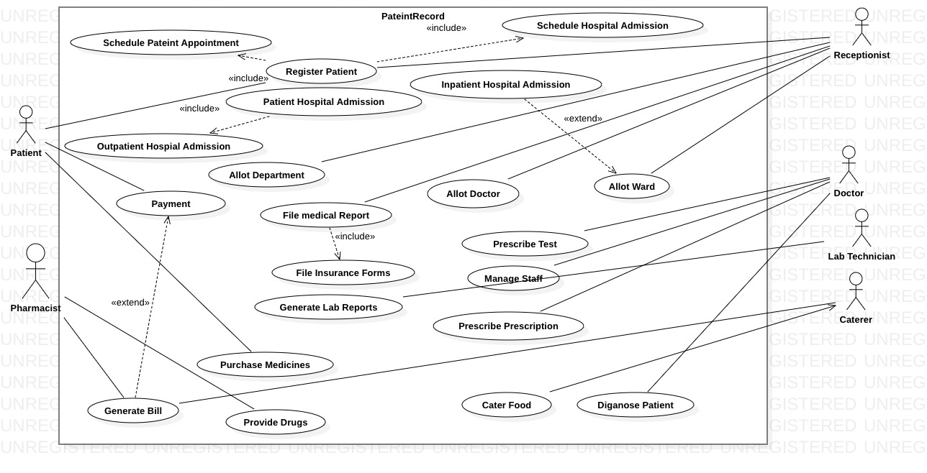

Figure 1

## 3. Write the class diagram (with specification classes)

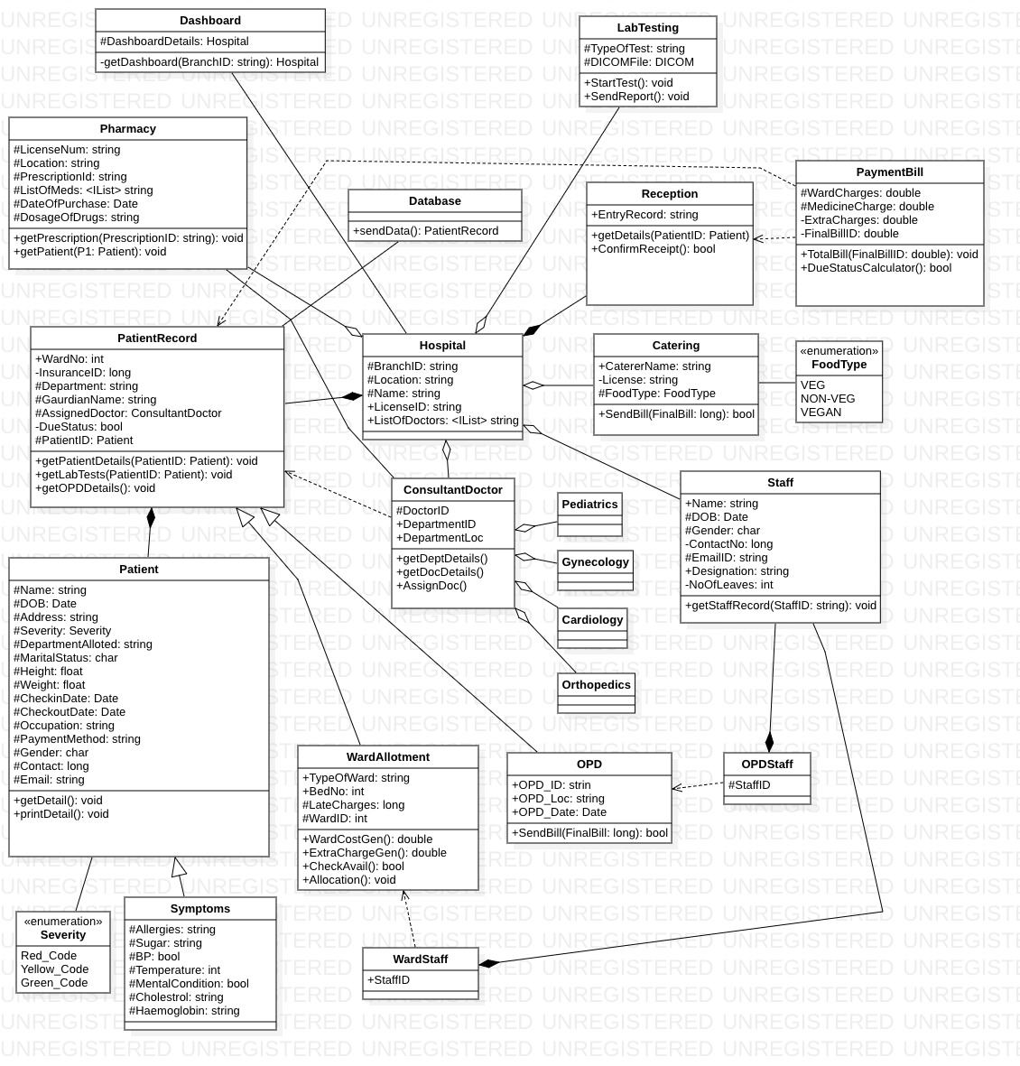

Figure 2

## 4. Give interaction diagrams for at least three use cases

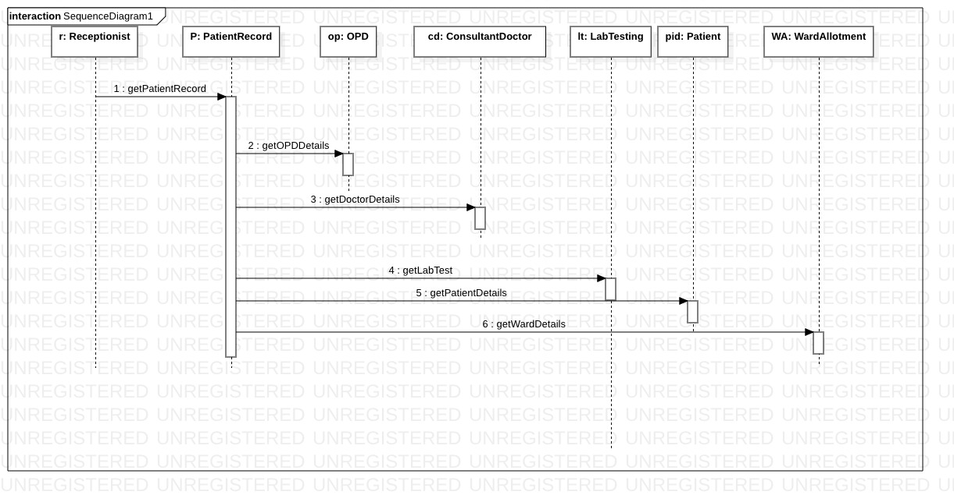

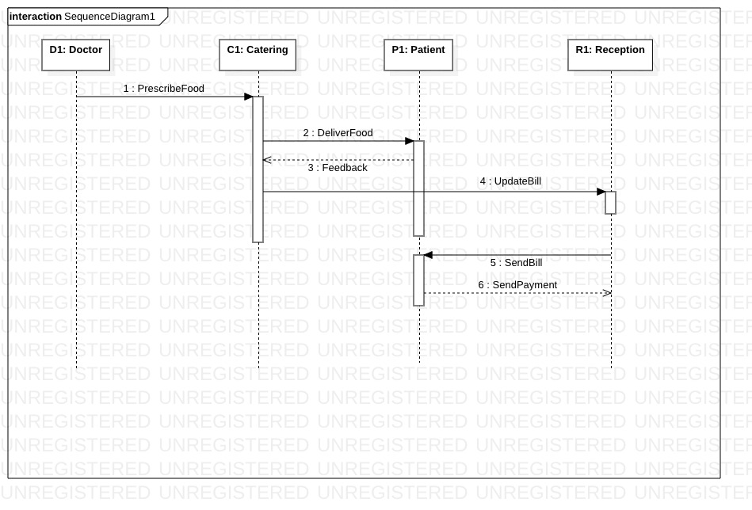

Figure 4 (Catering Food)

Figure 3 (Register Patient)

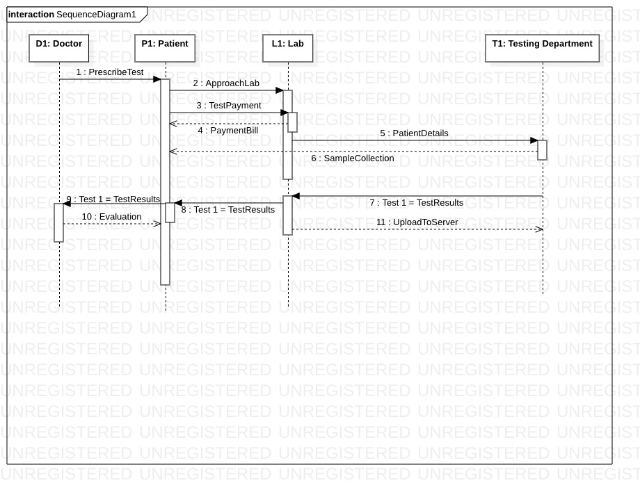

Figure 5(Generate Lab Reports)

## 5. Give activity diagram for the whole system

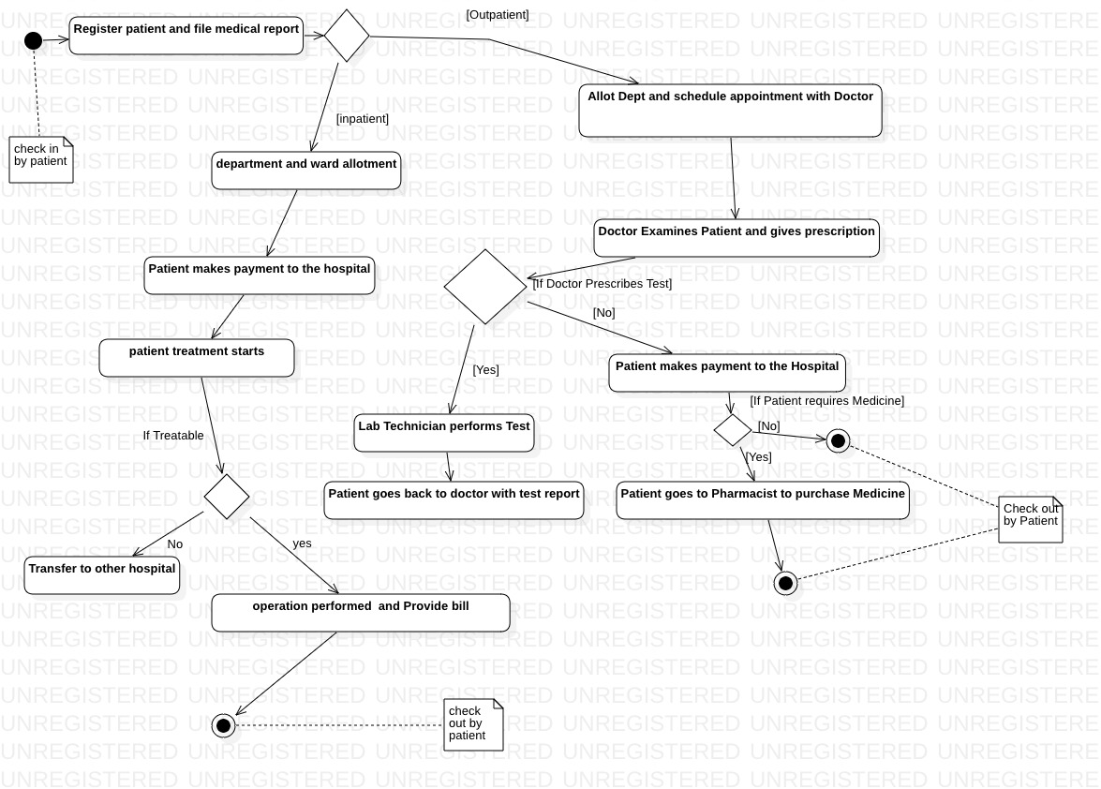

Figure 6

## 6. Show the package diagram of the entire system with clear separation of 3 layers of software architecture

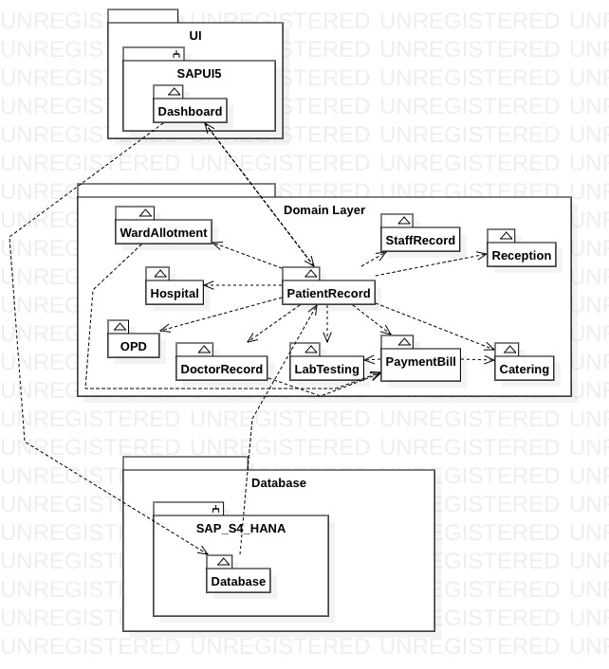

Figure 7

## 7. Generate the source code in Star UML with the language of your choice

import java.util.*;

/**

*

*/

public class WardStaff {

/**

* Default constructor

*/

public WardStaff() {

}

/**

*

*/

public void StaffID;

}

import java.util.*;

/**

*

*/

public class WardAllotment extends WardAllotment {

/**

* Default constructor

*/

public WardAllotment() {

}

/**

*

*/

public string TypeOfWard;

/**

*

*/

public int BedNo;

/**

*

*/

protected long LateCharges;

/**

*

*/

protected int WardID;

/**

* @return

*/

public double WardCostGen() {

// TODO implement here

return 0.0d;

}

/**

* @return

*/

public double ExtraChargeGen() {

// TODO implement here

return 0.0d;

}

/**

* @return

*/

public bool CheckAvail() {

// TODO implement here

return null;

}

/**

* @return

*/

public void Allocation() {

// TODO implement here

return null;

}

}

import java.util.*;

/**

*

*/

public class Symptoms extends Patient {

/**

* Default constructor

*/

public Symptoms() {

}

/**

*

*/

protected string Allergies;

/**

*

*/

protected string Sugar;

/**

*

*/

protected bool BP;

/**

*

*/

protected int Temperature;

/**

*

*/

protected bool MentalCondition;

/**

*

*/

protected string Cholestrol;

/**

*

*/

protected string Haemoglobin;

}

import java.util.*;

/**

*

*/

public class Staff {

/**

* Default constructor

*/

public Staff() {

}

/**

*

*/

public string Name;

/**

*

*/

protected Date DOB;

/**

*

*/

protected char Gender;

/**

*

*/

private long ContactNo;

/**

*

*/

protected string EmailID;

/**

*

*/

public string Designation;

/**

*

*/

private int NoOfLeaves;

/**

* @param StaffID

* @return

*/

public void getStaffRecord(string StaffID) {

// TODO implement here

return null;

}

}

/**

*

*/

public enum Severity {

Red_Code,

Yellow_Code,

Green_Code

}

import java.util.*;

/**

*

*/

public class Reception {

/**

* Default constructor

*/

public Reception() {

}

/**

*

*/

public string EntryRecord;

/**

* @param PatientID

*/

public void getDetails(Patient PatientID) {

// TODO implement here

}

/**

* @return

*/

public bool ConfirmReceipt() {

// TODO implement here

return null;

}

}

import java.util.*;

/**

*

*/

public class Pharmacy {

/**

* Default constructor

*/

public Pharmacy() {

}

/**

*

*/

protected string LicenseNum;

/**

*

*/

protected string Location;

/**

*

*/

protected string PrescriptionId;

/**

*

*/

protected <IList> string ListOfMeds;

/**

*

*/

protected Date DateOfPurchase;

/**

*

*/

protected string DosageOfDrugs;

/**

* @param PrescriptionID

* @return

*/

public void getPrescription(string PrescriptionID) {

// TODO implement here

return null;

}

/**

* @param P1

* @return

*/

public void getPatient(Patient P1) {

// TODO implement here

return null;

}

}

import java.util.*;

/**

*

*/

public class Pediatrics {

/**

* Default constructor

*/

public Pediatrics() {

}

}

import java.util.*;

/**

*

*/

public class PaymentBill {

/**

* Default constructor

*/

public PaymentBill() {

}

/**

*

*/

protected double WardCharges;

/**

*

*/

protected double MedicineCharge;

/**

*

*/

private double ExtraCharges;

/**

*

*/

private double FinalBillID;

/**

* @param FinalBillID

* @return

*/

public void TotalBill(double FinalBillID) {

// TODO implement here

return null;

}

/**

* @return

*/

public bool DueStatusCalculator() {

// TODO implement here

return null;

}

}

import java.util.*;

/**

*

*/

public class PatientRecord {

/**

* Default constructor

*/

public PatientRecord() {

}

/**

*

*/

public int WardNo;

/**

*

*/

private long InsuranceID;

/**

*

*/

protected string Department;

/**

*

*/

protected string GaurdianName;

/**

*

*/

protected ConsultantDoctor AssignedDoctor;

/**

*

*/

private bool DueStatus;

/**

*

*/

protected Patient PatientID;

/**

* @param PatientID

* @return

*/

public void getPatientDetails(Patient PatientID) {

// TODO implement here

return null;

}

/**

* @param PatientID

* @return

*/

public void getLabTests(Patient PatientID) {

// TODO implement here

return null;

}

/**

* @return

*/

public void getOPDDetails() {

// TODO implement here

return null;

}

}

import java.util.*;

/**

*

*/

public class Patient {

/**

* Default constructor

*/

public Patient() {

}

/**

*

*/

protected string Name;

/**

*

*/

protected Date DOB;

/**

*

*/

protected string Address;

/**

*

*/

protected Severity Severity;

/**

*

*/

protected string DepartmentAlloted;

/**

*

*/

protected char MaritalStatus;

/**

*

*/

protected float Height;

/**

*

*/

protected float Weight;

/**

*

*/

protected Date CheckinDate;

/**

*

*/

protected Date CheckoutDate;

/**

*

*/

protected string Occupation;

/**

*

*/

protected string PaymentMethod;

/**

*

*/

protected char Gender;

/**

*

*/

protected long Contact;

/**

*

*/

protected string Email;

/**

* @return

*/

public void getDetail() {

// TODO implement here

return null;

}

/**

* @return

*/

public void printDetail() {

// TODO implement here

return null;

}

}

import java.util.*;

/**

*

*/

public class Orthopedics {

/**

* Default constructor

*/

public Orthopedics() {

}

}

import java.util.*;

/**

*

*/

public class OPDStaff {

/**

* Default constructor

*/

public OPDStaff() {

}

/**

*

*/

protected void StaffID;

}

import java.util.*;

/**

*

*/

public class OPD extends OPD {

/**

* Default constructor

*/

public OPD() {

}

/**

*

*/

public strin OPD_ID;

/**

*

*/

public string OPD_Loc;

/**

*

*/

public Date OPD_Date;

/**

* @param FinalBill

* @return

*/

public bool SendBill(long FinalBill) {

// TODO implement here

return null;

}

}

import java.util.*;

/**

*

*/

public class LabTesting {

/**

* Default constructor

*/

public LabTesting() {

}

/**

*

*/

protected string TypeOfTest;

/**

*

*/

protected DICOM DICOMFile;

/**

* @return

*/

public void StartTest() {

// TODO implement here

return null;

}

/**

* @return

*/

public void SendReport() {

// TODO implement here

return null;

}

}

import java.util.*;

/**

*

*/

public class Hospital {

/**

* Default constructor

*/

public Hospital() {

}

/**

*

*/

protected string BranchID;

/**

*

*/

protected string Location;

/**

*

*/

protected string Name;

/**

*

*/

public string LicenseID;

/**

*

*/

public <IList> string ListOfDoctors

}

import java.util.*;

/**

*

*/

public class Gynecology {

/**

* Default constructor

*/

public Gynecology() {

}

}

/**

*

*/

public enum FoodType {

VEG,

NON-VEG,

VEGAN

}

import java.util.*;

/**

*

*/

public class ENT {

/**

* Default constructor

*/

public ENT() {

}

}

import java.util.*;

/**

*

*/

public class ConsultantDoctor {

/**

* Default constructor

*/

public ConsultantDoctor() {

}

/**

*

*/

protected void DoctorID;

/**

*

*/

public void DepartmentID;

/**

*

*/

public void DepartmentLoc;

/**

*

*/

public void getDeptDetails() {

// TODO implement here

}

/**

*

*/

public void getDocDetails() {

// TODO implement here

}

/**

*

*/

public void AssignDoc() {

// TODO implement here

}

}

import java.util.*;

/**

*

*/

public class Catering {

/**

* Default constructor

*/

public Catering() {

}

/**

*

*/

public string CatererName;

/**

*

*/

private string License;

/**

*

*/

protected FoodType FoodType;

/**

* @param FinalBill

* @return

*/

public bool SendBill(long FinalBill) {

// TODO implement here

return null;

}

}

import java.util.*;

/**

*

*/

public class Cardiology {

/**

* Default constructor

*/

public Cardiology() {

}

}